Player Safety in the NFL through Azure

Parker Green

November 26, 2019

Microsoft Software and Systems Academy

Server and Cloud Administration

**Player Safety**

One of the most high visibility issues in the National Football League (NFL) today is player safety, concussions specifically. A concussion is a type of traumatic brain injury—or TBI—caused by a bump, blow, or jolt to the head or by a hit to the body that causes the head and brain to move rapidly back and forth. This sudden movement can cause the brain to bounce around or twist in the skull, creating chemical changes in the brain and sometimes stretching and damaging brain cells (CDC, 2019). It is a frequent occurrence in the NFL for players to suffer this injury in game, and studies show that one concussion can lead to more. If a person has suffered three concussions, they then become three times more likely to have more.

The long-term effects of a concussion are the most concerning factor in this situation. Those who have suffered a concussion can have symptoms later in life such as trouble concentrating, personality change/disorder, sleep disturbances, and depression and other psychological problems. The NFL’s statistics show that in 2017 there were 281 recorded instances of concussion, but in 2018 that number fell to 214, which is a 23.8 percent decrease, thanks to recent rule changes with an emphasis on player safety. Although the number has decreased there are still improvements that can be made in identifying concussions, because the majority of concussions go unidentified.

**Riddell Insite, Current Microsoft Surface use**

A system that could support increased detection and standardized recording of concussions in the NFL would be integrating the sports equipment company Riddell’s Insite technology, alongside the already in place Microsoft Surface Pro tablets that teams have access to on the sidelines of each game. Riddell’s InSite Player Management Software (ISPM) installs on both Windows and Mac computers and allows coaches and trainers to create and edit a team roster, add and manage Alert Monitor and Player Unit assignments, and review impact Alert data downloaded from the Alert Monitors. Alert information can be reviewed and exported as an Excel file for further analysis (Riddell, n.d.). This data could be analyzed on site during games or practice and with already in place technology, would have an entry point into Azure for creation of the player safety database.

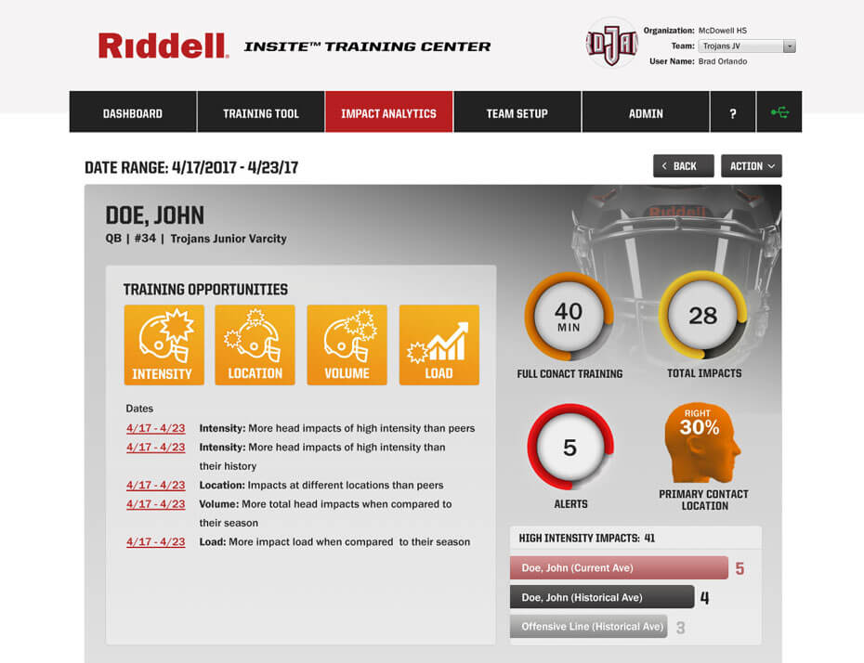

Riddell Insite Training Center Application (exportable to excel)

Currently only coaches are able to use Surface Pro tablets to view still images of plays that have occurred during the game, and the tablet is locked on that application. With the new system a separate group of tablets would be issued to the medical staff of each team. Each tablet will access a virtual machine on an Azure resource group. The tablet will also have Riddell’s online application, synced up to the alert monitors that are in each player’s helmet. This would allow the medical staff of each team to accurately detect concussions in real time, as well as have a recorded database of player health information and history throughout the year.

**Integration to Azure**

The creation of this database with help from the online application from Riddell, it is possible to export the data to Excel or OneNote. This spreadsheet can be expanded upon by each team and then added into Azure. Adding this data into Azure allows for an integrated approach for all teams to house their player health information. The benefits are medical staff can view player history and trends, look at doctors notes from previous injuries, and if a player is traded to another team the new team can view the information from previous years that has been recorded.

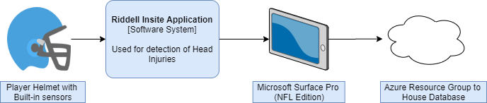

**Treatment and use of the database**

Being able to see the history of concussions for players is a big factor in treating concussions. There are over 21 different signs and symptoms post-concussion, and knowing these can help medical staff in the process. By using this data medical staff can cater their pre- season health assessments, post-season health assessments, and give them greater insight during an in-game evaluation where a player injury would occur. During all of these evaluations medical staff are able to identify if a player needs to rest for an upcoming game, even if the player feels like they are physically able to perform. This data can also help identify trends in the data for players. For example, if a player tends to suffer injuries late in the fourth quarter, mitigation strategies could be put in place to help the player avoid injuries when he is worn-out and maybe not using proper tackling techniques.

**Summary**

The NFL’s new focus on player safety and mitigation of concussions has shown positive results from 2017 to 2018 with a 23.8 percent reduction in reported concussions. Using technology can help in identifying concussions that may have previously gone unnoticed. Once the injury has been identified having an integrated database through Azure at their disposal, medical staff can increase the effectiveness of their pre-season, post-season, and in-game evaluations of concussions to better develop a medical plan for players moving forward.

**References**

INNOVATION. (n.d.). Retrieved November 26, 2019, from https://www.riddell.com/innovation/.

What Is a Concussion? (2019). Retrieved November 26, 2019, from https://www.cdc.gov/headsup/basics/concussion_whatis.html.